PIZZA SALES REPORT
KPI’s:
- Total Revenue:
SELECT
ROUND (SUM (total_price),2) AS Total_Revenue
FROM pizza_sales;
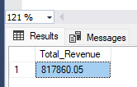

- Average Order Value:
SELECT
ROUND (SUM (total_price)/COUNT (DISTINCT order_id),2) AS Avg_order_value
FROM pizza_sales;
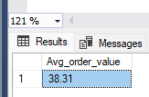

- Total pizzas Sold:
SELECT
SUM (quantity) AS Total_Pizzas_Sold
FROM pizza_sales;
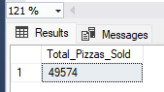
- Total Orders:
SELECT COUNT (DISTINCT order_id) AS Total_Orders
FROM pizza_sales;
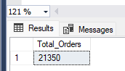

- Average Pizzas per Order:
SELECT
CAST (CAST (SUM (quantity) AS DECIMAL (10,2))/
CAST (COUNT (DISTINCT order_id) AS DECIMAL (10,2))
AS DECIMAL (10,2)) AS Avg_pizza_per_order
FROM pizza_sales;
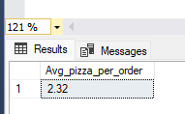

CHARTS REQUIREMENT:
- Daily Trend For Orders:
SELECT
DATENAME(DW, order_date) AS Order_Day,
COUNT(DISTINCT order_id ) AS Total_Orders
FROM pizza_sales
GROUP BY DATENAME(DW, order_date);

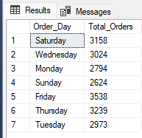

- Monthly Trend for total Orders:
SELECT
DATENAME(MONTH, order_date) AS Month_Name,
COUNT(DISTINCT order_id ) AS Total_Orders
FROM pizza_sales
GROUP BY DATENAME(MONTH, order_date)
ORDER BY Total_Orders DESC;
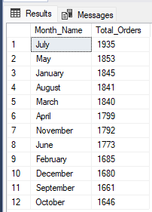

- Percentage of Sales by Pizza Category:
SELECT
pizza_category,
CAST(SUM(total_price) * 100/ (
SELECT SUM(total_price)
FROM pizza_sales
WHERE MONTH(order_date) = 1)AS DECIMAL(10,2)) AS Percentage_of_sales
FROM pizza_sales
WHERE MONTH(order_date) = 1
GROUP BY pizza_category;

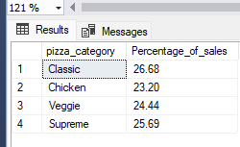

- Percentage of Sales by Pizza Size:
SELECT
pizza_size, CAST(SUM(total_price)AS DECIMAL(10,2)) AS Total_Sales,
CAST(SUM(total_price) * 100/ (
SELECT SUM(total_price)
FROM pizza_sales
WHERE DATEPART(QUARTER ,order_date) = 1) AS DECIMAL(10,2)) AS Percentage_of_sales
FROM
pizza_sales
WHERE DATEPART(QUARTER ,order_date) = 1
GROUP BY
pizza_size
ORDER BY Percentage_of_sales DESC;
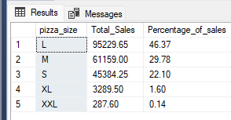
- Top 5 best Sellers by Revenue, total quantity and total orders.
SELECT TOP 5
pizza_name,
SUM(quantity) AS Total_Quantity,
SUM(total_price) AS Total_Revenue,
SUM(order_id) AS Total_Orders
FROM pizza_sales
GROUP BY pizza_name
ORDER BY Total_Revenue DESC;
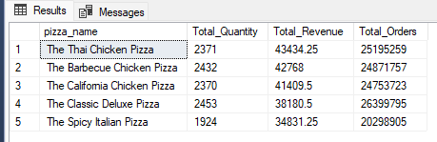
- Bottom 5 best Sellers by Revenue, total quantity and total orders.
SELECT TOP 5
pizza_name,
SUM(quantity) AS Total_Quantity,
SUM(total_price) AS Total_Revenue,
SUM(order_id) AS Total_Orders
FROM pizza_sales
GROUP BY pizza_name
ORDER BY Total_Revenue ASC;
